Attendance:

Items arising from previous meeting:

Current Items:

* QA Manual
* Functional Spec.
* Stuart Questions

AOB:

* Ideas:

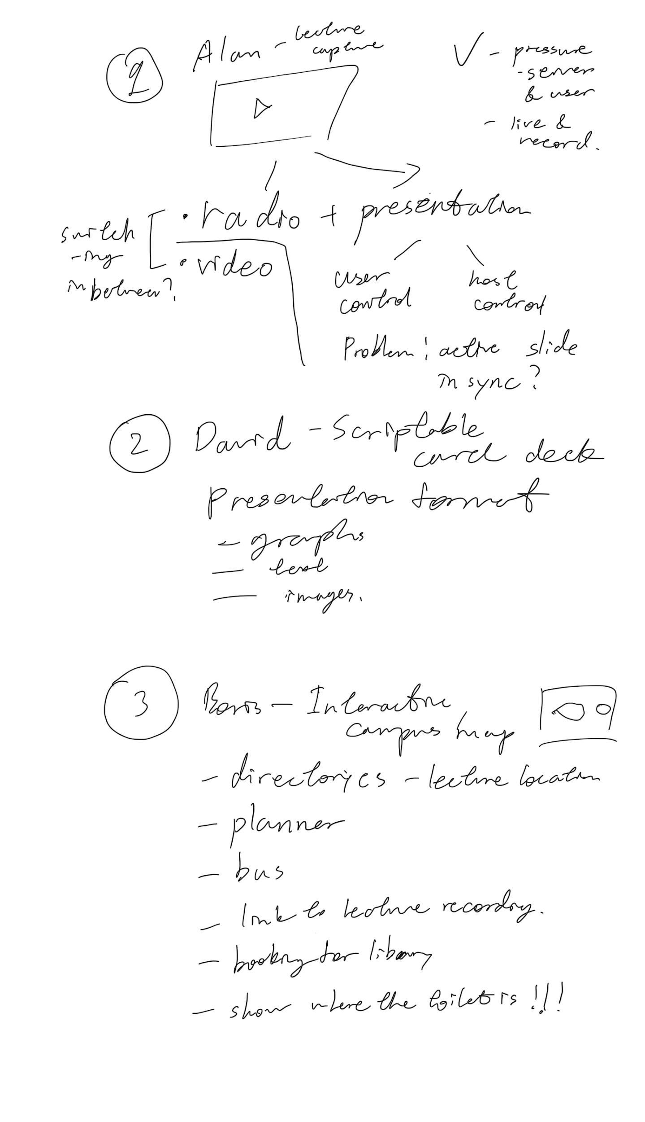

Actions Arising:

* Decide on initial idea
* Draft functional specification
* Next meeting in the same week?

There being no further business, the meeting was adjourned at 16:55.